# Union assignments

**Mandatory**

1. **Refer the code below and comment on size of the given structure considering**
   1. **Structure as union**
   2. **Structure as struct**
   3. **arr**
   4. **uarr**

___ Job

{

char name[32];

unsigned short ucount;

float salary;

int workerNo;

char *orgname;

};

___ Job myvar; //could of union or of struct

Struct Job arr[10];

Union Job uarr[10];

1. charà32 bytes

unsigned shortà2 bytes

float à4 bytes

int à4 bytes

char *à4 bytes

Total :46 bytes

a. structure as union: 32 bytes

b. structure as struct :46 bytes

c. arr : 10*46 bytes=460

d. uarr: 10*32 bytes=320

1. **Refer Job datastructure in Q#1 above. Using uarr, perform below operations.**
   1. **Read and store salary**
   2. **Read and store workerNo**

**Comment on values of output if salary and workerNo are printed in order. Justify your statement.**

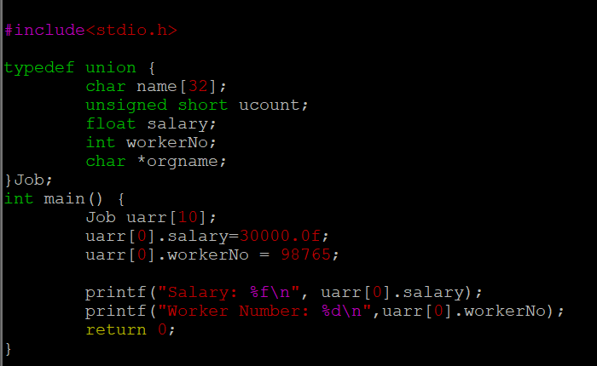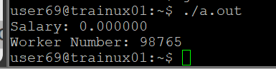

In unions only 32 bytes are created for the structure. When workerNo is given the salary is overridden so we do not get the salary output.

1. **Refer Job datastructure in Q#1 above. Assume that myvar is a structure variable. If I need to place 2 bytes (i.e 0x0102) as ucount using a char *ptr then list all possible statements that can be used in _____.**

**[Let solutions include cases such as**

* + 1. **using base address of ucount**
    2. **using relative address of ucount w.r.t to base address of myvar]**

int main()

{

char *ptr = &myvar;

___________ = 0x01;

___________ = 0x02

}

A. i) *ptr =0x01;

*(ptr+1)= 0x02

ii) As ucount is at 32 we directly access that bit

*(ptr+32)=0x01;

*(ptr+33)=0x02;